Iperf3 network Tester
  - An independent software-engineering research study
  - Project Retropsective and Final Report
Author: Jerry Abramson with Claude Code
Date: 2026-08-03
Status: Project Complete
Local AI Detals challenges and Assistants utilized: See Appendices
Research Synopsis: Document the initial Goals, unexpected Challenges encountered,, and How They Were Resolved.

Preface
An Android application was originally developed as a graduate Android-development course project, motivated by real-world use.
A 7 week directed study was undertaken with the primary goal of delivering the same application on all modern mobile platforms (Android, iOS) using Kotlin Compose Multi-platform (KMP).
Inherent in the development exercise was the extensive use of AI agents running locally and cloud based.

Project Goals
All major goals associated with the code deliverable and research analysis have been met, and a complete code release, with supporting documentation, is available on this GitHub release page:
https://github.com/jerryabramson/iperf3KMP/releases

Initial code sharing goal metric | ~80% Code Sharing
Actual achieved metric  - AI provided objective analysis | 76.6% – 81.7% shared (depending on methodology; down from 82.0% – 87.7% measured in August — see Appendix G and Appendix H for details).
The 80% goal was met.

Goals Achieved along with unexpected challenges
The founding goals of the project: port an existing native Android iperf3-testing app to a single Kotlin Multiplatform codebase, and drive real network tests rather than a simulation:

Item | Unexpected Challenge | Resolution / Outcome
Single shared UI across: 1. Android  2. iOS  3. bonus: Desktop | Compose Multiplatform was new territory; state handling (e.g. ViewModel state lost on device rotation) and layout needed rework for very different screen shapes (phone portrait vs. landscape vs. tablet vs. desktop window). | Ported to a common ViewModel/StateFlow architecture; UI reflows for wide displays and compresses vertical chrome on landscape phones. Rotation-state bug fixed.
Clean monospace output | Local AI hit a road block and was unable to resolve. | A Frontier model and significant user testing was required.
Persist a completed execution to local RoomDB database | See Appendix B | Utilized RoomDB + KMP SQLite
Run real iperf3, not a simulated/mocked test | See Appendex A | In-process libiperf 3.21 linked on all three targets.

Project Architecture
NOTE: AI Generated, and then refined, using:
- https://mermaid.ai/
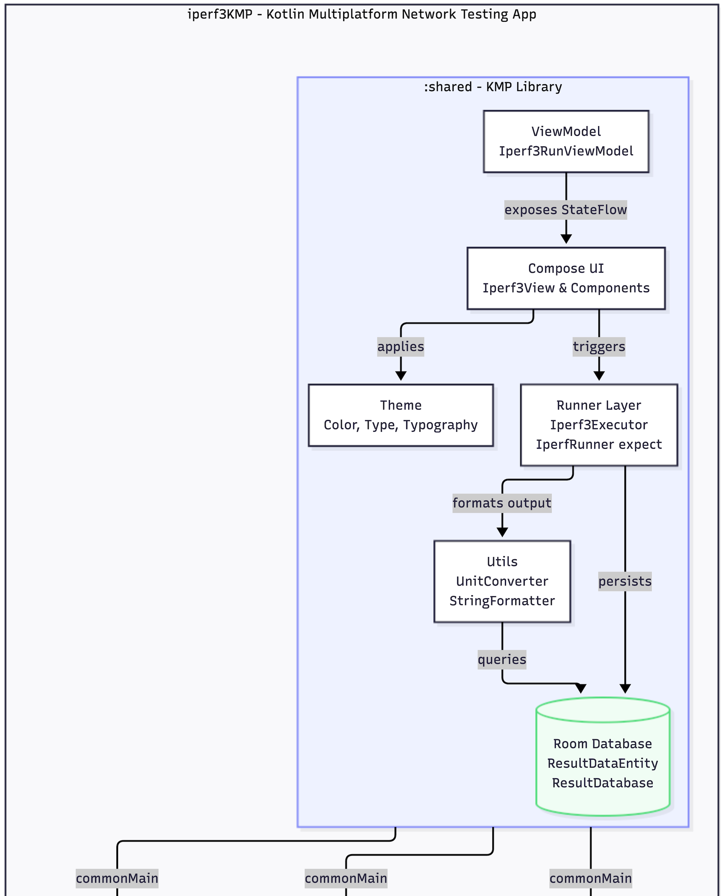 | 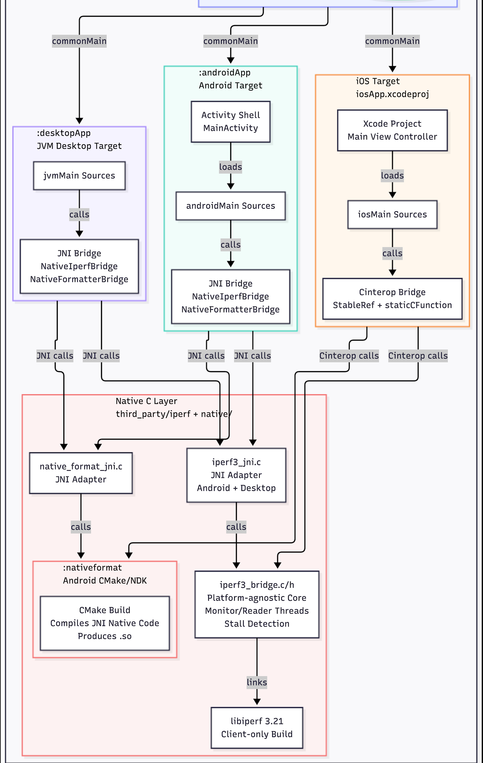

KMP Architectural Overview
The following two diagrams summarize the overall KMP architecture, along with the benefits, of KMP.

Low Code Sharing | Medium Code sharing | Goal for this project

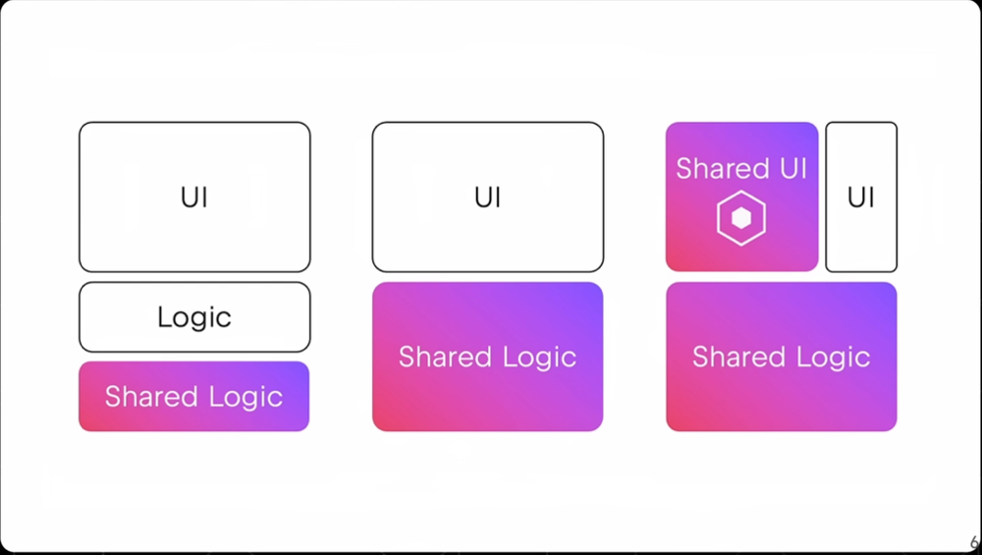

Android | iOS | Desktop (Mac/Windows) | Web

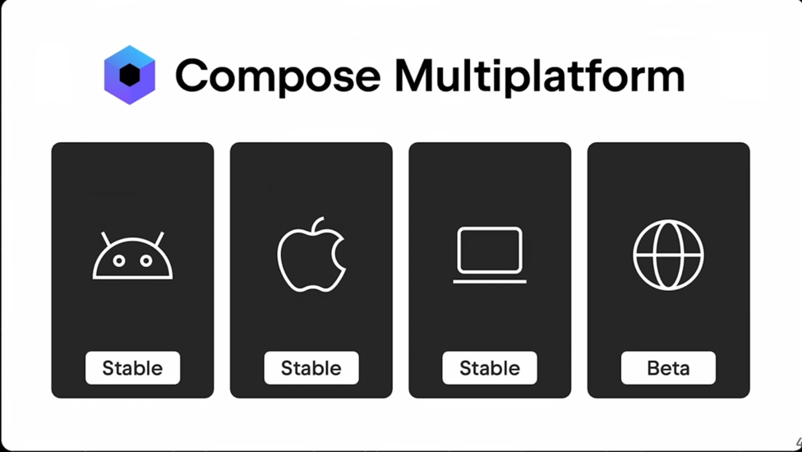

Appendix A Native iperf3 Integration — Runtime Bugs
Once the JNI/cinterop plumbing existed, real libiperf surfaced its own bugs and platform quirks, none of which were visible from documentation alone.
Item | Unexpected Challenge | Resolution / Outcome
iperf3 3.21 reentrancy bug | `i_errno` is a bare global that helper functions only ever *set*, never clear, on success — fine for iperf3's own CLI (parses arguments once per process) but wrong for a library caller re-parsing repeatedly in one long-lived process; caused spurious argument-parse failures. | Reset `i_errno = 0;` before every parse in the bridge layer. Filed upstream: esnet/iperf issue #2063.
Stall-detection watchdog thread | First version's timer reset every iteration regardless of real progress (so it could never fire); once fixed naively, it then false-positived during legitimate slow test startup. | Anchored the timer to real progress (bytes sent/received) and gated the false-positive case behind a `seen_any_progress` flag.
stderr misattributed as iperf3 errors (Android) | Capturing iperf3's own `warning()` output required redirecting the whole process's stderr via `dup2()` — which also captured unrelated Skia/GL renderer debug spam from Compose's own UI, silently marking otherwise-successful tests as failed. | `warning()` always writes a fixed `"warning: "` prefix; the stderr reader thread only forwards lines matching that prefix.
iOS needed a real compiled static library, not header-only cinterop | Unlike the printf work, `iperf3_bridge.c` couldn't just be `static inline` — iperf3's logic is genuinely stateful. Device and simulator arm64 also turned out not to be link-compatible with each other despite sharing an instruction set (different SDKs). | New Gradle tasks cross-compile iperf3 + the bridge into per-target `libiperf3bridge.a` (device and simulator built separately), linked via cinterop `-staticLibrary`/`-libraryPath`.
No on-device `./configure` for iOS | iOS has no shell to run iperf3's real `./configure` step the way Android's NDK/desktop builds do. | Hand-authored `iperf_config_ios.h`, copied directly from the `./configure`-generated header this project's own macOS desktop build already produces (iOS shares macOS's Darwin/BSD sockopt surface).
JNI portability: Linux clang vs. macOS clang | Three `AttachCurrentThread` calls passed `&env` where JNI's spec requires `void **env` — Apple's clang only warned; a typical Linux clang treats it as a hard build error. | Added the missing `(void **)` casts at all three call sites.

Appendex B. Local Persistence (Room + KMP SQLite)
Goal: save each completed test result to a real on-device database on all three platforms, following a Google codelab pattern (CODELAB_ROOMDB.md / ROOMDBPLAN.md) that had only ever been exercised on Android + iOS, never a JVM desktop target.
Item | Unexpected Challenge | Resolution / Outcome
Silent UUID/timestamp corruption | `AppUUID`/`AppLocalDateTime` only declare `val name: String`, no `toString()` override — calling `.toString()` (as the first mapper implementation did) silently returned Kotlin's default `ClassName@hashcode` instead of the real value, which would have made every saved row's GUID garbage and non-unique. | Always read `.name` on these types instead of `.toString()`.
Room DAO methods must be `suspend` off Android | The codelab's DAOs used plain blocking `fun`s, which compile fine on Android but fail KSP on JVM/iOS with "Only suspend functions are allowed in DAOs declared in source sets targeting non-Android platforms." | Converted every DAO method to `suspend`.
No destructive-migration fallback | A planned decision (`fallbackToDestructiveMigration`) was never actually wired into the builder; a schema-version bump then throws at runtime instead of dropping/recreating tables. | Added `.fallbackToDestructiveMigration(dropAllTables = true)`; schema JSON per version committed under `shared/schemas/` as the diffable history.
`Dispatchers.IO` not public on iOS | Room 2.8.4's own transitive `kotlinx-coroutines-core` resolves to a version where `Dispatchers.IO` is `internal` on iOS targets only — `commonMain` code referencing it fails to compile for iOS specifically, with no equivalent failure on Android/JVM. | Used `Dispatchers.Default` everywhere in the persistence path instead — public on all three targets.
Wrong SQLite driver artifact per source set | The codelab's advice (driver in `commonMain`) broke `:desktopApp:build` with an unresolved-`jvm`-platform error — `sqlite-framework` only publishes Android + Apple variants, no JVM variant exists at all. Android/iOS builds stayed green throughout, masking the break. | Split by source set: `androidx-sqlite-framework-android` (Android), `androidx-sqlite-framework` (iOS arm64 + simulator), `androidx-sqlite-bundled` (JVM/desktop).
iOS static framework doesn't propagate Gradle linker flags | `linkerOpts.add("-lsqlite3")` in Gradle was already set, but the Xcode app-link step still failed with "Undefined symbols ... _sqlite3_bind_blob" — because `Shared.framework` is built `isStatic = true`, so Xcode's own separate final link never sees Gradle's linker flags at all. | Added `OTHER_LDFLAGS = ("$(inherited)", "-lsqlite3")` directly to the Xcode project's own target-level build configurations, not just the Gradle side.

Apendix C. Desktop Packaging & Cross-Platform Distribution
Unplanned Goal achieved: ship installable macOS (.dmg), Windows (.msi), and Linux (.deb) desktop packages via Compose Multiplatform's jpackage wrapper.
Item | Unexpected Challenge | Resolution / Outcome
No cross-compiling is possible | The app isn't pure JVM — two native C libraries (printf helper, iperf3 JNI bridge) are compiled by `clang` at build time for whatever OS/arch Gradle is currently running on. | Documented as project policy: each installer format must be built on that actual OS; there is no equivalent of Android's per-ABI fat-binary splitting for desktop.
Linux link failure: missing `-fPIC` | The native compile steps had `-fPIC` only on the final link, not on the two `.o`-producing compile steps. macOS tolerated this silently; Linux's `ld.lld` correctly refused to link non-PIC objects into a `.so`. | Added `-fPIC` to both compile invocations.
Fresh-clone setup gaps (Linux) | A plain `git clone` doesn't pull the `third_party/iperf` submodule; and even a desktop-only build still requires a full, correctly-versioned Android SDK, because Gradle configures every subproject (including `:androidApp`) by default. | Documented exact recovery steps, including the Android "minor API level" package-ID gotcha (`platforms;android-37.0`, not `android-37`).
Packaged app had no icon (macOS) | In-app window icon and jpackage's installer/Dock icon are two separate mechanisms; jpackage also requires a different file *format* per OS (`.icns`/`.ico`/`.png`) and silently falls back to a generic icon rather than failing the build when given the wrong one. | Generated correct per-OS formats (`sips`+`iconutil` for `.icns`, ImageMagick for `.ico`) and wired both the in-app and installer icon mechanisms separately.
.deb naming inconsistency | Debian package-name policy forbids uppercase, so jpackage silently lowercases the package name and filename for `.deb` only — but not for `.dmg`/`.app`, and the launcher binary itself keeps the original casing even though its parent directory doesn't. | Documented the exact install paths (`/opt/iperf3kmp/bin/iperf3KMP`) so this isn't mistaken for a packaging bug on future Linux setups.

Appendix D. Windows Desktop — Investigated, Then Deliberately Not Shipped
The one platform target where a goal was abandoned rather than achieved, after substantial investment. Full build/troubleshooting history preserved on branch `win11_build`; not reproduced here since none of it is actionable without reopening the decision. See WINDOWS_DESKTOP_APP.md.
Update (2026-09-12): This decision was later reversed — see Appendix H, "Windows Desktop, Revisited — Decision Reversal and Updated Code-Sharing Findings." The paragraph above is left as-written, as the honest record of the decision at the time it was made.
Item | Unexpected Challenge | Resolution / Outcome
Goal: `packageMsi` parity with macOS/Linux | No POSIX-compatible toolchain exists for `third_party/iperf`'s POSIX-heavy C sources on native Windows (MinGW/MSVC lack sufficient header compatibility) — Cygwin's clang was the only viable path, and was made to work at the build level (compiled, linked, app UI launches). | Real toolchain fixes were applied and are documented (real `configure`/`make` via Cygwin bash, DLL bundling) — build success was achieved, this is not a documentation-only note.
Blocking runtime issue: JVM crash on test start | Cygwin-built DLLs dynamically link against Cygwin's own runtime (`cygwin1.dll`). Loading that runtime directly into `java.exe` — required by this project's in-process JNI design — is unreliable: the JVM's unusually large/nonstandard memory layout collides with Cygwin's runtime-init shared-memory requirements, crashing with `EXCEPTION_ACCESS_VIOLATION`. Reproduced consistently even after `rebaseall`, Cygwin's own standard remedy for this exact class of error. | No fix exists that preserves the in-process JNI design.
The only known workaround re-introduces a rejected architecture | Avoiding the crash entirely requires running the Cygwin-compiled iperf3 code as a separate child process (the same way the official `iperf3.exe` itself is built) rather than in-process — which is exactly the `ProcessBuilder`-subprocess design this project already built once for Android and deliberately replaced with in-process JNI, specifically to avoid subprocess lifecycle/output-parsing/permission complexity. | Decision: Windows desktop marked unsupported rather than maintain two fundamentally different execution architectures for one feature. README/INDEX updated accordingly; not a gap left unexamined, a reasoned trade-off.

Appendix E. Bugs Only Found by Running the Real App
Every row here compiled cleanly and, where a test existed, passed — each was only caught by a human actually looking at a running device. See AI_ASSISTED_DEVELOPMENT_LIMITS.md for why this category doesn't shrink just because a stronger model writes the code.
Item | Unexpected Challenge | Resolution / Outcome
Android-only column misalignment | `mesloFontFamily()` silently fell back to the generic `FontFamily.Monospace` alias instead of the bundled Meslo Nerd Font, on Android only — traced via git archaeology to a dead, unused resource import dating back to the very first KMP-port commit. | Fixed to reference the bundled font directly. Verified by eye on Android, iOS, and desktop.
iOS gibberish output text | The original `NSString.stringWithFormat`-based printf port produced mangled host/port and garbage numeric columns live in the output panel on-device — not a crash or hang, just wrong rendered text, only visible from a screenshot. | Root cause: the vararg/FFI bug in Section A. Fixed by the shared native-format redesign; primary evidence kept at docs/evidence/ios-printf-gibberish-output.png.
Light-mode summary labels invisible | `LightColorScheme.secondary` was near-white, making the Min/Avg/Max summary labels unreadable in light mode only — a pure visual defect invisible to any compiler or test. | Matched the dark scheme's `PurpleGrey40` value for the same role.
ViewModel state lost on screen rotation | State was not preserved across a device rotation, only discoverable by physically rotating a device. | Fixed in the ViewModel/state-restoration layer.
macOS packaged app crashed on pressing Start | An astral-plane emoji (rocket, U+1F680) passed through JNI's `NewStringUTF` from a synchronous native startup callback — codepoints above the Basic Multilingual Plane are undefined behavior for `NewStringUTF`'s modified-UTF-8 encoding, silently corrupting JVM heap and aborting the process one frame later, inside an unrelated subsequent JNI call. | Replaced the astral-plane emoji with distinct BMP-safe symbols per message meaning (▶ start, ✅ success, ⏹ stopped, ⚠ error) in both the native C bridge and the Kotlin UI strings. Verified with real runs on macOS desktop, iPad Max M4, and iPhone 17 Pro. Committed as ca5253c, shipped as a v1.1 hotfix release.
iOS background execution (open item) | iOS suspends network sockets once the app backgrounds, cutting a long-running test short — no compiler or test signal for this, since the app behaves correctly while foregrounded. | In progress at time of writing: experimenting with location-permission entitlements as a way to keep the process alive in the background. Not yet resolved or verified end-to-end.

Appendix F. Research Findings
Local vs. Cloud LLM Agentic Coding
The project's second, explicit goal : use iperf3KMP's real development history as evidence for a local-vs-cloud LLM capability comparison.
Full writeups:
- LMSTUDIO_MCP_CASE_STUDY.md
- PRINTF_FORMATTING_CASE_STUDY.md
- AI_ASSISTED_DEVELOPMENT_LIMITS.md.
Item | Unexpected Challenge | Resolution / Outcome
Local-LLM web-search tool access (LM Studio + MCP) | Expected to be routine configuration; instead required diagnosing three independent, stacked root causes across three machines: macOS GUI apps not inheriting shell `PATH`, macOS's separate Local Network privacy permission, and a personal `.zshrc` bug that silently dropped any non-interactive `zsh -c` command project-wide. | All three fixed and documented ($5.41, ~18 min of real API compute, per `/cost`). Became the case study's core evidence for sustained multi-hop diagnostic reasoning.
Local model capability on the printf/vararg bug | A local model (`qwen/qwen3.6-35b-a3b`) was expected to at least attempt platform-correct printf formatting; instead it shipped a build that silently produced wrong output on iOS, without surfacing the underlying FFI/vararg constraint at all. | Root-caused and rebuilt via the native C bridge architecture (Section A); became the reference example for the whole project's native-interop pattern.
Local model reasoning gap even with decoupled tool access | Hypothesis: local models' failures might be an artifact of routing tool access entirely through the one broken MCP subsystem being diagnosed (a bootstrapping confound). | Retested via `opencode` (independent tool implementations, same as Claude Code) — same local models still could not correlate logs against live process state or read third-party source to find the load-bearing bug. Confirmed a genuine reasoning-capability gap, not just a tooling-wiring artifact.
A frontier model's own unverified fix | Not anticipated at project start: even Claude's own font-alignment fix (Section F) compiled clean and had nothing to test against, yet its correctness was not knowable by any model — including the model that wrote it — until a human looked at a real screen. | Became the project's core research thesis: perceptual/visual correctness is a category no AI model can close by getting stronger, because the missing ingredient is a sensory channel, not intelligence (AI_ASSISTED_DEVELOPMENT_LIMITS.md).
Local-model safety / blast radius | Not part of the original research scope; surfaced when local models given unrestricted agent tool access, in separate prior work, took destructive, unintended actions while pursuing an incorrect fix. | Adopted as a documented operational requirement: every local-model session runs on a disposable branch/worktree, never directly on a primary branch.

Appendex G. Notes on Code Sharing Methodology

Results by Methodology
Methodology | Shared  lines | Platform-specific  lines | Total | Shared %
Kotlin production code only — commonMain vs. all androidMain / iosMain / jvmMain actuals plus the three app-shell entry points (MainActivity.kt, main.kt, iOSApp.swift) | 5,953 | 1,337 | 7,290 | 81.66%
Same as above, with unit/instrumented tests included (commonTest, androidHostTest, iosTest, jvmTest) | 6,234 | 1,552 | 7,786 | 80.07%
Same as row 2, plus the native C interop layer — the platform-agnostic bridge (native_format.h, iperf3_bridge.c/.h) counted as shared; the JNI adapters and per-OS config headers counted as platform-specific | 7,070 | 2,158 | 9,228 | 76.61%

Goals:
- Single shared UI across Android / iOS
- Real iperf3 network execution, not a simulated/mocked test.
- Kotlin `vararg` printf-style formatting across all targets
- Bonus Goal: Deliverable on KMP desktop: MacOS and Linux

Raw Line Counts by Source Set
Physical line counts (wc -l) per Gradle source set / native file, from the tracked source tree (git ls-files), as of this release.
Source set / file | Lines | Scope
shared/src/commonMain (Kotlin) | 5,953 | Shared — all 3 platforms
shared/src/commonTest (Kotlin) | 281 | Shared — all 3 platforms
native/native_format.h + iperf3_bridge.c/.h | 836 | Shared — all 3 platforms (JNI + cinterop)
shared/src/androidMain (Kotlin) | 232 | Android only
shared/src/androidHostTest (Kotlin) | 11 | Android only (test)
androidApp/ (Kotlin, MainActivity.kt) | 26 | Android only
shared/src/iosMain (Kotlin) | 498 | iOS only
shared/src/iosTest (Kotlin) | 58 | iOS only (test)
iosApp/ (Swift, ContentView.swift + iOSApp.swift) | 30 | iOS only
shared/src/jvmMain (Kotlin) | 501 | Desktop only
shared/src/jvmTest (Kotlin) | 146 | Desktop only (test)
desktopApp/ (Kotlin, main.kt) | 50 | Desktop only
native/iperf3_jni.c + native_format_jni.c | 371 | Android + Desktop only (JNI adapters)
native/iperf_config_android.h | 91 | Android only (native build config)
native/iperf_config_ios.h | 100 | iOS only (native build config)
native/native_log.h | 44 | iOS only (os_log() shim for developer-mode logging)

Source of truth. All counts are physical lines (wc -l) over files returned by `git ls-files` in the final release — i.e. exactly what's tracked in version control, not an estimate or a build-tool report.
The native C layer is the one architectural wrinkle. Most of this project's cross-platform logic is Kotlin, sharable via commonMain in the ordinary KMP way. The one exception is the real iperf3 client integration, written in C for performance/library-compatibility reasons. Its core logic (test lifecycle, threading, stall detection, output filtering) is written once and reached identically by JNI on Android/desktop and by Kotlin/Native cinterop on iOS — genuinely shared source, just not Kotlin source. Only the thin JNI glue and two per-OS config headers are truly single-platform.
Why three rows instead of one number. The strictest, most conventional definition of "KMP code sharing" (production Kotlin only) gives the highest figure, 81.7% (down from 87.7% in August). Including tests and the native layer both pull the number down further, and 76.6% — the most inclusive, most conservative row — is the number this document has always said to cite if asked to defend the figure under scrutiny. That row is now below the original 80% goal. See Appendix H for what changed and why this is presented as an open question rather than a resolved verdict.
Why three rows instead of one number. The strictest, most conventional definition of "KMP code sharing" (production Kotlin only) gives the highest figure, 87.7%. Including tests and the native layer both pull the number down somewhat, and 82.0% — the most inclusive, most conservative row — is the number to cite if asked to defend the figure under scrutiny, since it counts the fewest things as "free" shared code.

Appendix H. Windows Desktop, Revisited — Decision Reversal and Updated Code-Sharing Findings
Appendix D recorded a considered decision, made in good faith with the information available at the time, not to ship Windows desktop support. That decision was later revisited and reversed: Windows desktop support shipped on the windows_msi_bundling branch. The full narrative — what changed, why the original rejection was reasonable given what was known then, and how the new architecture (a ProcessBuilder-driven real iperf3.exe process, rather than the in-process JNI path used on the other platforms) made it viable — is documented in full in WINDOWS_DECISION_REVERSAL_CASE_STUDY.md, in the same style as this project's other case studies. It is not reproduced here; this appendix summarizes only the two findings most relevant to this report's own goals section.
Finding 1: the architectural prediction held.
Before writing any Windows-specific code, the case study predicted the Windows runtime delta would cost roughly three percentage points of code sharing (≈89% → ≈86% on that document's own methodology). The actual, measured delta was 88.3% → 85.7% — close to the prediction, and confirming the underlying theory: the amount of Windows-specific code needed was genuinely small (247 net runtime lines, confined to jvmMain), because the work already done to get third_party/iperf building under Cygwin's toolchain was reused rather than duplicated. The build-time logic required to make that reuse work (roughly 343 net lines, across several new Gradle tasks) is arguably more complex than the runtime changes themselves — an asymmetry worth naming plainly, since it means the project's real Windows cost shows up almost entirely outside the code-sharing metric's own accounting (build scripts are excluded from every row, per Appendix G's stated methodology).
Finding 2: the 80% goal is now a genuinely open question, not a settled one.
Independent of the Windows work, Appendix G's three code-sharing rows were remeasured against the current tracked source tree (identical methodology, git ls-files + wc -l, three rows from strictest to most inclusive). The range moved from August's 82.0%–87.7% down to 76.6%–81.7%. The two strictest rows still clear 80%; the most inclusive row — the one this document has always said to cite under scrutiny — does not. Two legitimate engineering additions account for essentially the entire drop: Windows desktop support (above) and a small expect/actual developer-mode logging utility, whose per-platform actuals (android.util.Log, println, Apple's os_log) were never going to be shareable, no matter how they were written. Neither addition was platform-specific for its own sake; both were real capabilities one platform needed and the others didn't.
That is precisely what makes the resulting question worth stating rather than resolving: is a KMP project that adds a real, necessary capability still meeting an "80% shared" goal, when the most conservative honest accounting says no? There is no methodology-independent answer. This report leaves it framed as an open question, consistent with how Appendix G's own "most conservative row" convention was written from the start — the point was never to always clear 80%, it was to always measure and report honestly, including when the number moves the wrong way.
A sharper version of the same tension: what the metric is actually measuring.
The high code-sharing percentage this project reports, at any point in its history, is partly a function of how deliberately uniform its UI was allowed to stay — not purely a measure of engineering discipline. The UI is entirely Compose Multiplatform text and form fields, carefully formatted but without result-history graphs, and the desktop build is a Compose window rather than a real desktop application in the platform-idiomatic sense — no native menu bar, no OS-integrated chrome, none of the affordances a user would expect from an app built to feel native on that platform. A version of this app with real charting, a native macOS/Windows menu bar, or iOS- and Material-idiomatic navigation instead of one shared screen layout would need meaningfully more platform-specific code, and would likely score lower on every row above — possibly well below 80% on the most conservative one. That would not make it a worse app; it would make it a more ambitious one, spending its platform-specific budget on native UI richness instead of holding that budget in reserve for a uniform cross-platform surface. The metric measures how much of the UI stayed uniform, not how good the UI is.
What this implies about the project's own scope, honestly stated.
The bulk of this project's genuinely hard engineering — real native iperf3 execution in-process on three platforms, the JNI/cinterop split, memory-growth avoidance, stall/deadlock detection, and the negative-testing discipline that surfaced and fixed real crashes rather than just passing happy-path tests — is done, and done to a real, live-verified standard. But the amount of new code a genuinely commercial, platform-idiomatic UI would require is not small, and is not the kind of work this project's single-developer-plus-AI-agent model is well-suited to estimate from the inside. A full commercial release, of the kind this project's broader goals (see project memory: ICSE 2027 presentation and app-store distribution) ultimately aim at, would plausibly need dedicated iOS, Android, and desktop UI specialists — not because Compose Multiplatform is deficient, but because native-feeling UI is inherently more platform-specific than the uniform, text-centric UI this project shipped. Whether KMP with Compose can still sustain a high code-sharing percentage once that richer, platform-idiomatic UI work is actually done is an open empirical question this project cannot answer on its own — that answer would require real UI specialist effort per platform, at a scale beyond what one developer working with AI assistance can produce or credibly evaluate.
This points to a broader thesis this project is now positioned to state, even though it cannot fully test it alone: full commercial application development still requires a skilled, multi-disciplinary development team — iOS, Android, and desktop UI specialists among them, not just backend/systems engineering of the kind this project's native-layer work represents. AI assistance, frontier or local, is a genuine force multiplier for that team, as this project's own development history and its companion research (see Appendix F) documents in detail. But augmentation is not substitution: the scope of a real commercial release — richer, platform-idiomatic UI across three targets, the design judgment that goes with it, and the breadth of manual verification a small team can parallelize and a single person cannot — appears to exceed what one human working with current AI tooling can produce or credibly validate alone, no matter how effectively that individual uses the tooling available. This report does not resolve that question with the rigor a controlled study would require; it names it, grounded in this project's own concrete experience, as the natural next research question the current results point to.

